ANTICLOCKWISE ROTATION OF STEPPER MOTOR USING 8051 USING PROTEUS

PROGRAM:

ORG 0000H
MOV P2, #0F0H ; Set P2 as output port

; Rotate motor in anticlockwise direction
ANTICLOCKWISE:
MOV P2, #09H ; Step 1 (1001)
ACALL DELAY
MOV P2, #03H ; Step 2 (0011)
ACALL DELAY
MOV P2, #06H ; Step 3 (0110)
ACALL DELAY
MOV P2, #0CH ; Step 4 (1100)
ACALL DELAY
SJMP ANTICLOCKWISE ; Loop back for continuous rotation

DELAY:
MOV R0, #255
D1: MOV R1, #255
D2: DJNZ R1, D2
DJNZ R0, D1
RET

END

OUTPUT:
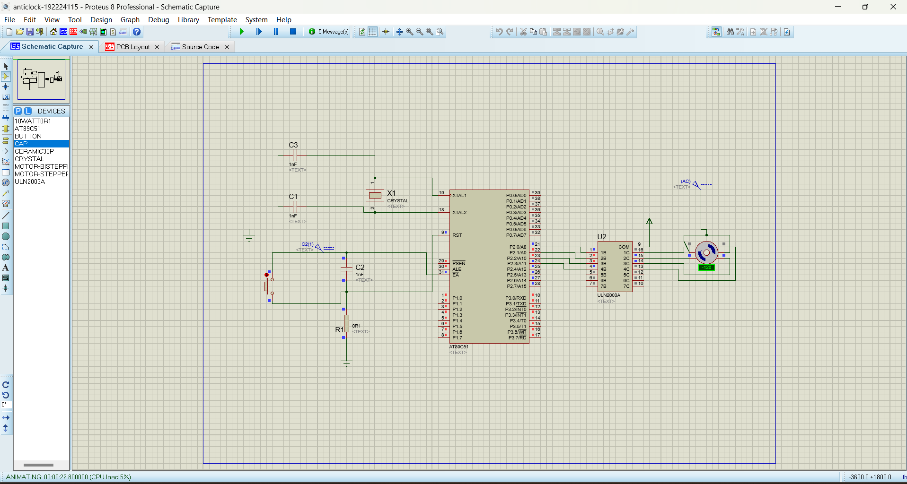
.Change value of DC from 0 to 5V
